- What is object technology? What do you perceive as object technology’s strength? Its weakness?
(一) Object technology:
A set of principles (abstraction, encapsulation, polymorphism) guiding software
construction, together with languages, databases, and other tools that support those
principles.//指导软件架构的principles和其他东西
(二) Strength:
Reflects a single paradigm//反映一个single的范例
Facilitates architectural and code reuse//促进架构和代码重用
Reflects real world models more closely//更接近地表示真实世界模型
Encourages stability//鼓励稳定
Is adaptive to change//适应变化
(三) Weakness:
The object technology emphasized the cooperation actually displays the order of
complexity which another violent characteristic - coupling degree is too high .
//强调合作

- What is UML? List at least three benefits of developing with UML.
(一) UML:
The UML is a language for Visualizing、Specifying、Constructing、Documenting the
artifacts of a software-intensive system.
//是一门可视化、详细说明、构造、证明软件集中系统的语言
(二) 好处：
There are things about a software system you can’t understand unless you build UML models.
//构建UML模型可以帮助你理解软件系统
An explicit model facilitates communication.
//明确的模型有利于交流
The UML builds models that are precise, unambiguous, and complete.
//UML建模是明确的，无二义性的，完整的

- What process/*过程*/ characteristic best fit the UML? Describe each characteristic.
The UML is largely process independent. A process fully benefits from the UML when
the process is: Use-case driven、Architecture-centric、Iterative and incremental.
(一) Use-case driven ：//用例驱动
Use cases defined for a system are the basis for the entire development process
Benefits of use cases:
Concise, simple, and understandable by a wide range of stakeholders. Help synchronize the content of different models.
(二) Architecture-centric ：//以构造为中心的
A system’s architecture is used as a primary artifact for conceptualizing,constructing, managing, and evolving the system under development.
Benefits:
● Intellectual control over a project to manage its complexity and to maintain system integrity.
● Effective basis for large-scale reuse.
● A basis for project management.
● Assistance in component-based development.
(三) Iterative and incremental：//迭代的，增值的
Critical risks are resolved before making large investments.
Initial iterations enable early user feedback.
Testing and integration are continuous.
Objective milestones focus on the short term.
Progress is measured by assessing implementations.
Partial implementations can be deployed.
- What is a use-case driven process? What is use-case? What are the benefits of use case?
(一) Use-Case Driven Process：
Use cases defined for a system are the basis for the entire development process.
(二) use-case:
Defines a set of use-case instances, where each instance is a sequence of actions a system performs that yields an observable result of value to a particular actor.
//一个系统perform的次序，产生一个显著的结果of value to a particular actor
A use case models a dialogue between one or more actors and the system
A use case describes the actions the system takes to deliver something of value
to the actor
(三) Benefits of use cases:
Concise, simple, and understandable by most stakeholders.
//简洁、简单，大部分利益相关人都能理解
Help synchronize the content of different models.
//帮助同步不同模型的内容
- What is system’s architecture? What is an architecture-centric Process?
A system’s architecture is used as a primary artifact for conceptualizing, constructing,
managing, and evolving the system under development.
首要制品for概念化、建设、组织、进化 系统under开发
- What is iteration? What are the benefits of Iterative Development?
(一) Iteration:
a single execution of a set of instructions that are to be repeated until a specified
result is obtained
一系列指令，被反复执行，直到获得一个规定的结果
(二) benefits of Iterative Development:
Critical risks are resolved before making large investments.//在大投入前解决风险
Initial iterations enable early user feedback.//早期迭代enable用户反馈
Testing and integration are continuous.//不停地测试和集成
Objective milestones focus on the short term.//短期目标里程碑
Progress is measured by assessing implementations.//进步用评估实现来丈量
Partial implementations can be deployed.//部分实现可以被部署
Each iteration produces an executable release, an additional increment of the system.
//每次迭代都产生可执行的发布
- What are the basic principles of OO technology? Describe each in detail.
(一) OO technology:抽象 封装 多态 继承
Abstraction Encapsulation Polymorphism Hierarchy
(二) Detail:
Abstraction:
● The essential characteristics of an entity that distinguishes it from all other
kinds of entities.
● Defines a boundary relative to the perspective of the viewer.
● Is not a concrete manifestation, denotes the ideal essence of something.
Encapsulation:
● Hides implementation from clients.
● Clients depend on interface.
Modularity:
● Breaks up something complex into manageable pieces.
● Helps people understand complex systems.
Hierarchy
Inherits is refers too use another object directly the attribute and the
method.
- What is use case model? Which artifacts can be included in a use case model?
(一) use case model:
A model that describes a system’s functional requirements in terms of use cases.
依据用例，描述系统功能性需求的模型。
(二) Artifacts:
actor，use case
- List three types of relationships existed between different use cases and give examples.
用例之间的联系：包括、延伸、泛化（继承）
Include
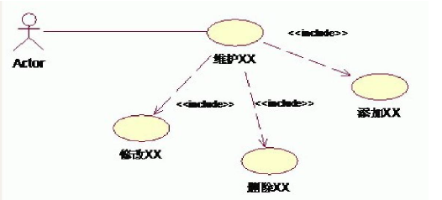
Extend
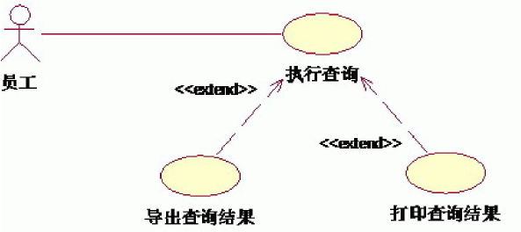
generalization
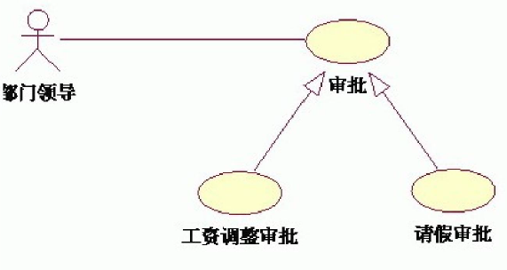
- Explain the following diagram and their elements with examples.
1) Use case diagram 2) Activity diagram 3) Sequence diagram 4) Collaboration diagram
5) Class diagram 6) state chart diagram 7) Deployment diagram
- Describe the similarities and differences between the sequence diagram and collaboration diagram.
顺序图描述对象之间的交互，使用"lifeline"和信息在他们之间的传递表现对象如何参与互动，强调时间。
通信图强调有组织的结构的对象之间的接收和发送信息，强调空间。

- Define the different relationships in class diagram: dependency, association, aggregation, composition, generalization.
Dependency：an object construct an instance of another object or rely on the service of another object.
//construct另一个对象的实例/依赖另外的对象提供的服务
Association is a structural relationship specifying that objects of one thing are connected
to objects of another thing.
Aggregation is an “is a part-of” relationship, it is a special form of association that
models a whole-part relationship between the aggregate (the whole) and its parts.
Composition is a relationship stronger than aggregation, a form of association.

Generalization is an “is a kind of” relationship, it is a relationship among classes where
one class shares the structure and/or behavior of one or more classes.
- What is a node in deployment diagram? List two different types of nodes.
- Describe the extensability mechanisms of UML.
Extensibility Mechanisms include Stereotypes, Tagged values, Constraints.
- What is the function of Stereotypes？Give two examples of stereotypes.
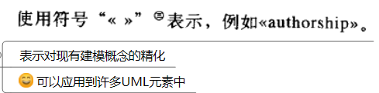
A particular abstraction, used at other places in the model to denote the associated abstraction, and Stereotypes help create new building blocks.
Examples : <<process>> or <<thread>>
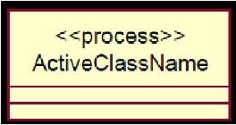
- 六个最佳实践
- 四个阶段
- “4+1”views
- 分析和设计的差异
- OOA、OOD的流程
- What is a layered architecture? Give examples of typical layers.
- What are analysis mechanisms? What are design mechanisms? Give examples.
- What is an analysis class? Name and describe the three analysis stereotypes. Give examples.
- What is Use-case realization? What‘s your understandings about the benefit of the use-case realization structure.
A use-case realization describes how a particular use case is realized within the design model, in terms of collaborating objects.
描述 某个用例 基于协作对象 如何在 设计模型 中实现
- Describe the steps occurred in the use-case analysis.
- What’s the package, and why we need package?
A package is something used to group elements, and to provide a namespace for the grouped elements.
package make all the classes, objects, use cases, components, nodes and node instances organized in it, thus making it possible for us to manage all the stuffs of the project.
- What is a subsystem? What is an interface? How does a subsystem differ from a package?
- What is the purpose of describing the run-time architecture? How to model the process view?
- What is the purpose of describing the distribution? How to model the deployment view?
- Describe the 3 typical distribution patterns, C/S , B/S and P2P.
- What is the agile process model? What is Scrum？What is XP？What are the differences among Scrum, XP and RUP?
- What is the object oriented design approach of GRASP? Please give 9 GRASP patterns with examples and definitions.
- What is the object oriented design approach of GoF? Please give 7 GoF patterns with examples and definitions.
- What is the relationships between the patterns of GoF and GRASP?

